**University of the Cordilleras**

**College of Information Technology and Computer Science**

CC12 – Statistical Design and Analysis

**Colab LabAct6: Test for Independence**

Problem 1:

Is educational attainment independent of race? In 2017, 300 Asians are asked about their educational attainment and 20% are high school graduates, 30% are with bachelor’s degree, 20% are with master’s degree, 5% are with doctoral degree and the rest are either no degree or not a high school graduate. Out of 400 African American, 33% are high school graduates, 15% are with bachelor’s degree, 10% are with master’s degree, 1% are with doctoral degree and the rest are either no degree or not a high school graduate. Out of 200 Latinos, 30% are high school graduates, 10% are with bachelor’s degree, 5% are with master’s degree, 1% are with doctoral degree and the rest are either no degree or not a high school graduate. Lastly, out of 100 White Americans, 30% are high school graduates, 25% are with bachelor’s degree, 10% are with master’s degree, 2% are with doctoral degree and the rest are either no degree or not a high school graduate. Use 95% confidence level.

**Observed Count**



**Expected Count**



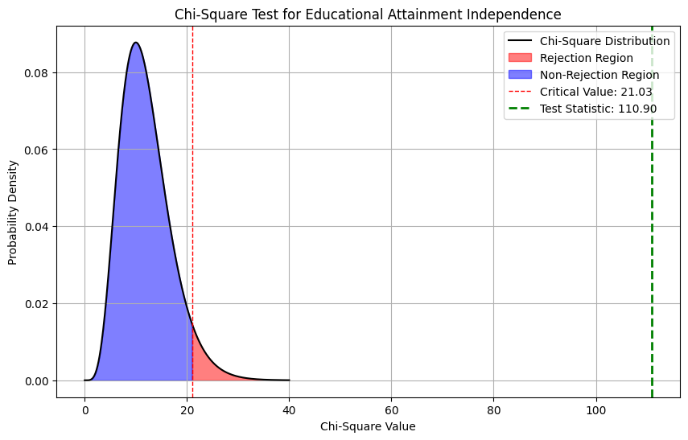**Curve**

**Conclusion**

Reject the null hypothesis: There is significant evidence that educational attainment is not independent of race.